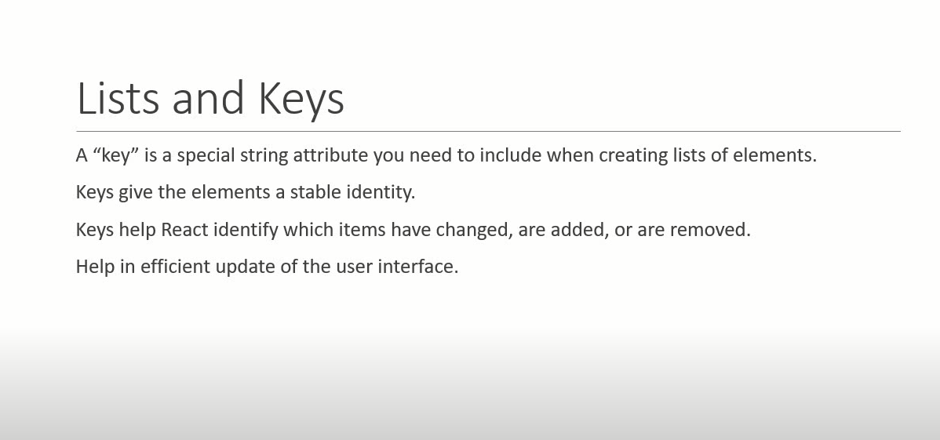

import React from 'react'

function PersonDetails() {

    const persons=[

        {id:1,name:'Subhishek',age:28,skill:'.Net core, React, Python,Sql'},

        {id:2,name:'Abhishek',age:28,skill:'.Net core, React, Python,Sql'},

        {id:3,name:'Dummy',age:28,skill:'.Net core, React, Python,Sql'},

    ]

    const lists= persons.map(person=> (

      <h4>{person.name} {person.age}</h4>

    ))

  return (

    <div>

      {lists}

    </div>

  )

}

export default PersonDetails

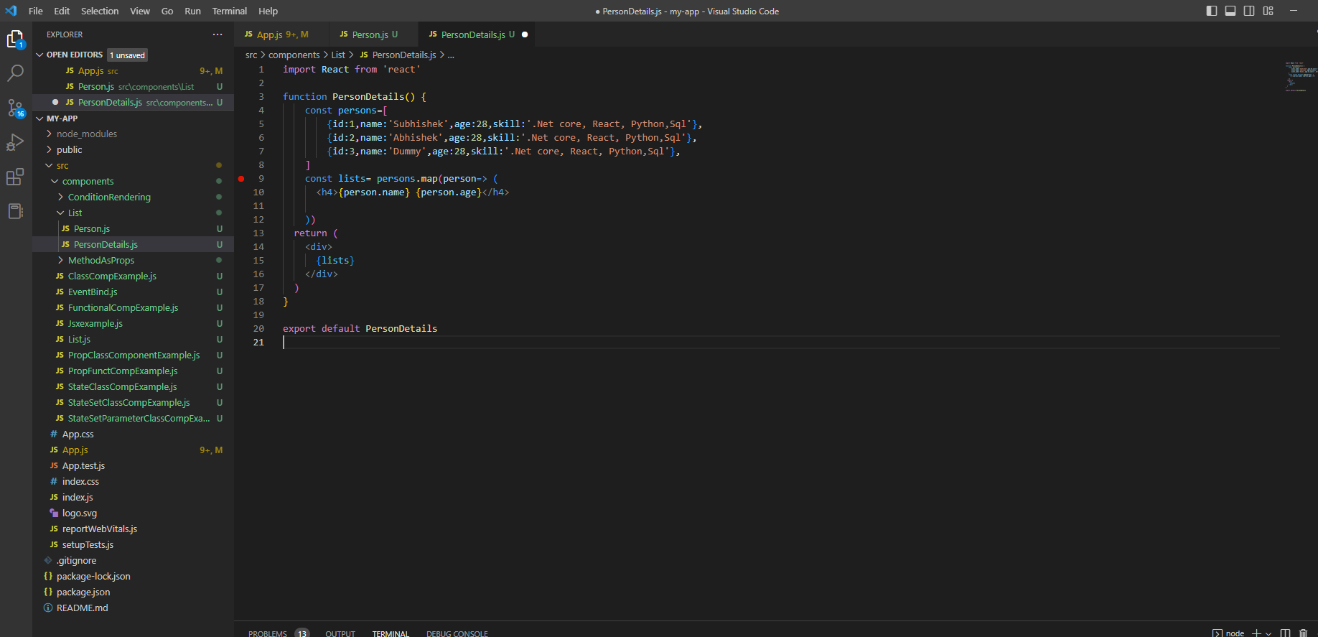

Refactor code :

For JSX code seprated in other component and access through prop .

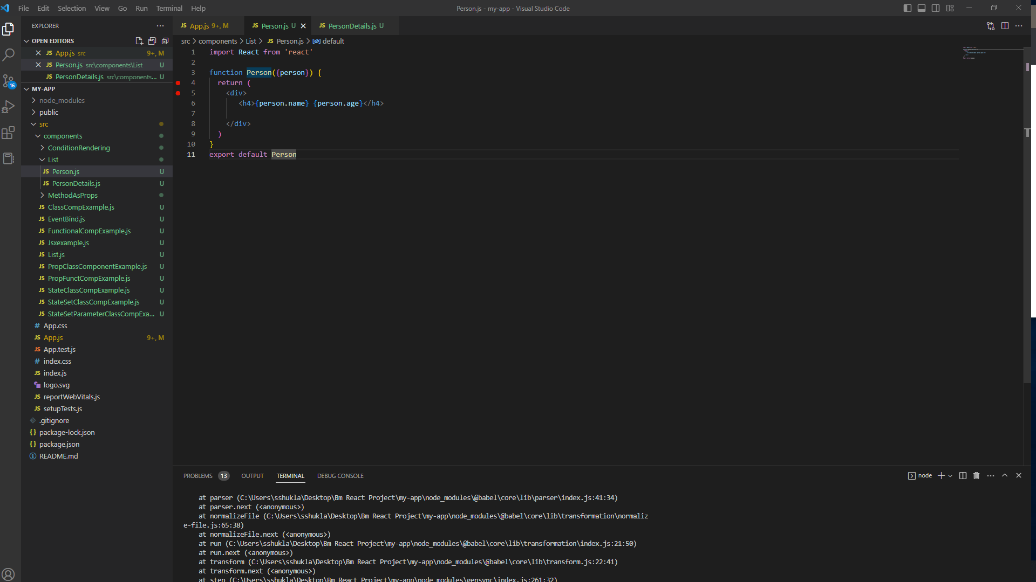

Use Separted jsx code into other component

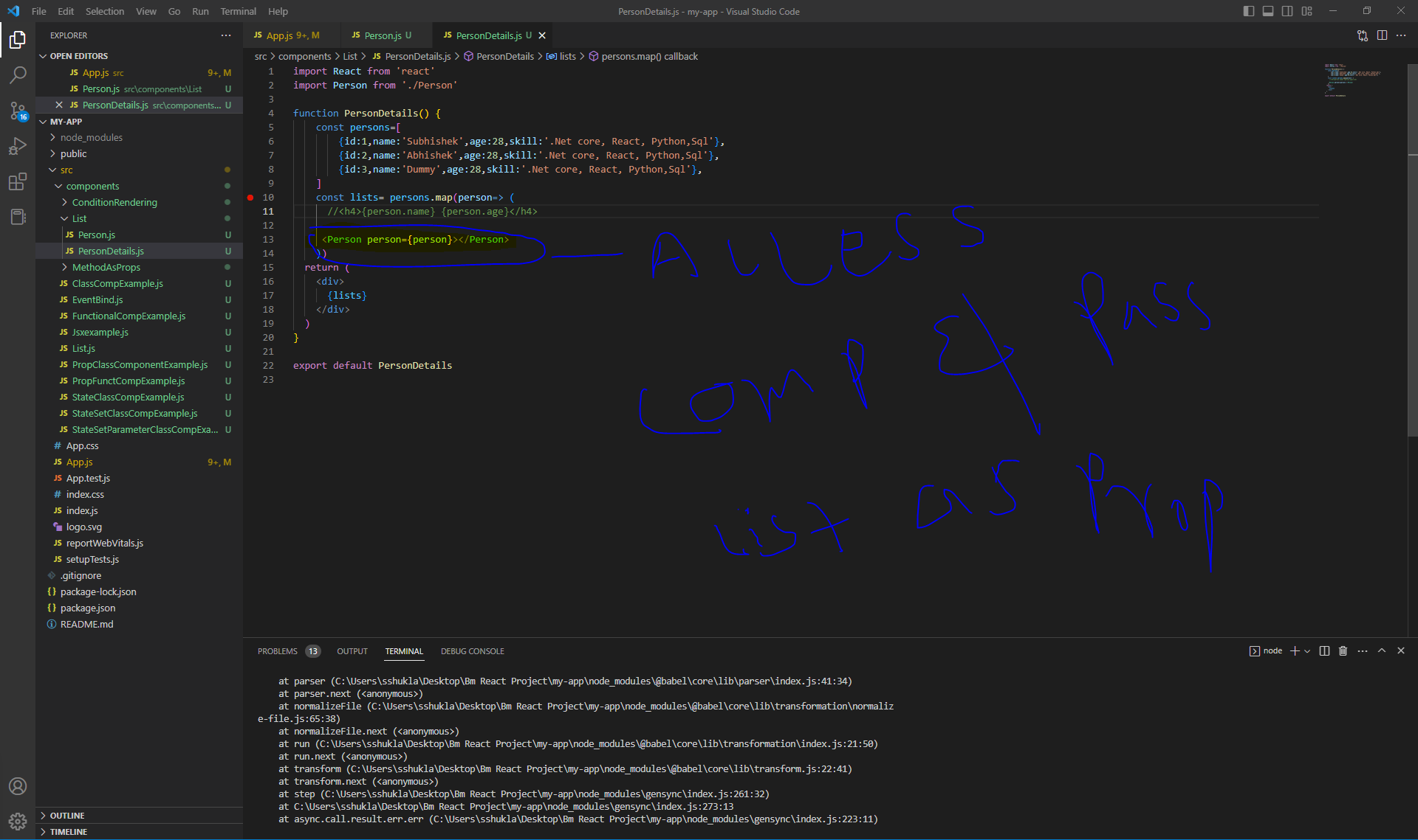

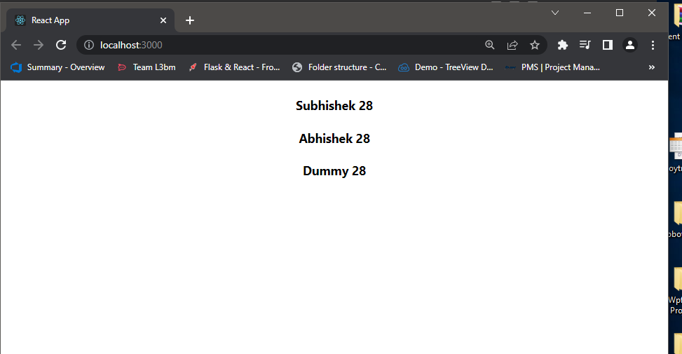

Keys :

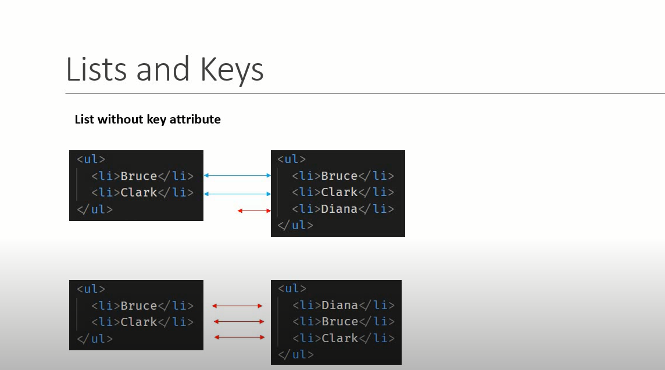

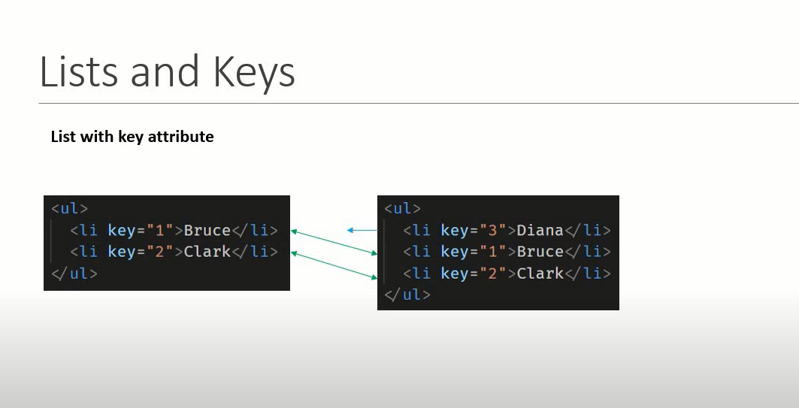

Add key to each record :

import React from 'react'

import Person from './Person'

function PersonDetails() {

    const persons=[

        {id:1,name:'Subhishek',age:28,skill:'.Net core, React, Python,Sql'},

        {id:2,name:'Abhishek',age:28,skill:'.Net core, React, Python,Sql'},

        {id:3,name:'Dummy',age:28,skill:'.Net core, React, Python,Sql'},

    ]

    const lists= persons.map(person=> (

      //<h4>{person.name} {person.age}</h4>

     <Person key={person.id} person={person}></Person>

    ))

  return (

    <div>

      {lists}

    </div>

  )

}

export default PersonDetails

When we have to use index as key ?

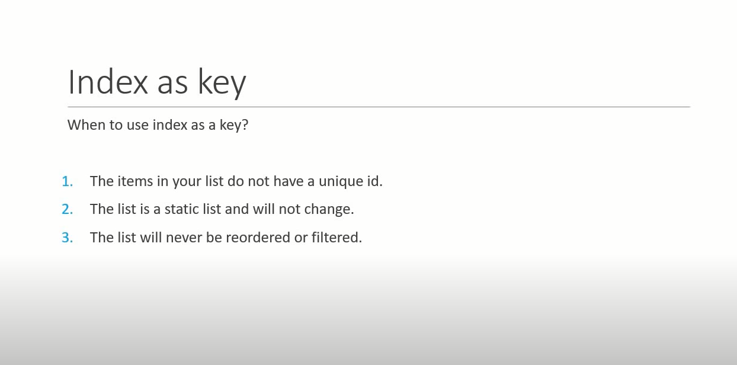

import React from "react";

function ListWithoutUniqueIdUseKey(){

    const names=['Subhishek','Lucka','Datrick','Milan','Lucka']

    const nameList=names.map((name,index)=> <h2 key={index}>{name}</h2>)

    return <div>{nameList}</div>

}

export default ListWithoutUniqueIdUseKey

//Arrow function accept two parameter

names.map((name,index)=> <h2 key={index}>{name}</h2>)

